Fuel Cycle Cost (FCC) model for Nuclear Fuel Cycle Simulation System (NFCSS) economic evaluation

Table of Contents
1. Mathematical model for estimating fuel cycle scenarios costs for Nuclear Fuel Cycle Simulation System (NFCSS) 1
2. Fuel Cycle Cost Template and User instructions for its utilizing 5
3. Example applications of the Excel template for Fuel Cycle Cost Calculation for PWR UOX, PHWR UOX, and PWR MOX reactor types. 9
4. Overall Fuel Cycle Cost calculation for a combination of reactor types based on the NFCSS scenario. 13
5. References 18
Annex I List of Excel files 20
Annex II IAEA tools for NES economic evaluation 21

- Mathematical model for estimating fuel cycle scenarios costs for Nuclear Fuel Cycle Simulation System (NFCSS)
Time value of money [1-3]
Fuel Cycle Cost (FCC) model for NFCSS is based on the present value methodology assuming discounting the time series of expenditures to the present value in a specific base year by applying a discount rate. In general, NFCSS scenario can consist of multiple reactor types and fuel cycle facilities. Expenditures for such nuclear energy system scenario includes building, operating and maintaining, and fuel cycle costs. Each nuclear reactor produces electricity during the operation period which generates revenues. As these expenditures and revenues occur at different points in time, they cannot be added together to determine the economics of the nuclear energy system. They should be discounted to a reference point, for NFCSS scenario it can be start year of modelling horizon. This approach uses the concept “time value of money”.
Under this concept, an expenditure which occurs far into the future would have a lower weight compared to the expenditure occurring in the near future. The process of converting future sum of money to a present date is called discounting and the rate used is called discount rate. Basically, discount rate is a representation of “time value of the money” and is the standard unit for evaluating the decrease of worth of the money. The choice of a discount rate depends on an overall economic, regulatory and commercial situation in a country. Formula to determine the present value (P) of a future sum of money (Fₜ) expected at time t, is: P = F_{t} / (1+r)^{t} . The calculation with this formula is known as the discounted present value or worth of the future amount.

Nuclear Power Plant (NPP)-level economic evaluation [1,2]
Let first consider a scenario with one reactor unit. The cumulative discounted expenditures during NPP lifetime can be written using Eq. (1):

$\sum_{t}{\frac{I_{t}+O\&M_{t}+F_{t}}{(1+r)^{t}}}$ (1)
Where I_{t} – capital expenditures at year t, O&M_{t} – O&M expenditures at year t; F_{t} – fuel expenditures at year t; r – the discount rate.
The cumulative discounted income by selling NPP electricity can be calculated using Eq. (2):
$\sum_{t}{\frac{E_{t}*R_{t}}{(1+r)^{t}}}$ (2)
where E_{t} – electricity generation at year, R_{t} – electricity price in year t (in a general case it is a time dependent value).
One of a transparent and widely applied measure of generating costs of a power plant is levelised unit energy cost (LUEC) or levelized cost of electricity (LCOE). It is the per unit constant cost that would cover all expenses incurred on the project over its life including cost of construction, cost of maintenance, and cost of fuel. It can be derived from the equality of present value of expenditures to present value of revenues:

$\sum_{t}{\frac{E_{t}*LUEC}{(1+r)^{t}}}= \sum_{t}{\frac{(I_{t}+O\&M_{t}+F_{t})}{(1+r)^{t}}}$ (3)
LUEC therefor equals cumulative discounted expenditure divided by the cumulative discounted electricity:
$LUEC={\sum_{t}{\frac{(I_{t}+O\&M_{t}+F_{t})}{(1+r)^{t}}}}/{\sum_{t}{\frac{E_{t}}{(1+r)^{t}}}}$ (4)
All values in LUEC are discounted to the power plant start-up. LUEC comprises follow components: the capital costs, the operation and maintenance costs and the fuel cycle costs.
Fuel cycle costs are dependent on the reactor type and its associated fuel cycle. The nuclear fuel preparation processes for different reactors vary and thus require different steps.
Scenario-level economic evaluation [4-6]
For the scenario with multiple reactors and fuel cycle facilities the levelised generation costs (LGC) can be represented in similar way as cumulative discounted expenditure for all reactor types and their fuel cycles divided by the cumulative discounted electricity produced by all reactors during time horizont under consideration :

$LGC=\frac{\sum_{t}{\frac{\sum_{i=1}^{n}{{I_{i}}_{t}+O\&{M_{i}}_{t}+{F_{i}}_{t}}}{{\left(1+r\right)}^{t}}}}{\sum_{t}{\frac{\sum_{i=1}^{n}{E_{it}}}{{\left(1+r\right)}^{t}}}}$, | (5)
where i=1, …, n is the reactor type index.
For one reactor unit under operation within the considered time horizon, LGC equals to LUEC.
Note on discount, inflation and escalation rates. [1-3,7]
Two types of discount rates can be used for expenditure discounting: nominal and real discount rates. The nominal rate is applied when the calculation considers inflation, and the real rate is used when the project is calculated in constant costs, i.e., the inflation rate is excluded from the discount rate.
Inflation refers to the general increase in prices of goods and services across an economy, leading to a decline in purchasing power. Escalation refers to the rise in prices of specific goods or services. It includes the effect of general inflation as well as a real increase in prices due to other reasons, such as supply-demand conditions, resource depletion, regulations, etc. The difference between escalation and inflation is that the escalation is the rise in prices of specific goods or services whereas inflation is the rise in prices of a basket of goods and/or services. The real escalation is the increase in prices over and above general inflation.
The analyst has the choice of making an economic analysis in current money by including the effect of inflation, or in constant money by disregarding the effect of inflation. Current money means money as spent or earned. Future payments in constant money are calculated using real escalation and real discount rates [1, 2, 13].
IAEA publication [1] recommends using real rates and future payments in constant money for LCOE/LUEC analysis.
NFCSS material flow model and fuel cost calculation [1,5-7]
Fuel Cycle Cost model for NFCSS considered only fuel cycle costs including cumulative discounted fuel costs (CDFC) and levelised generation fuel cost (LGFC), which are dependent on the reactor type and its associated fuel cycle.

$CDFC=\sum_{t}{\frac{F_{t}}{(1+r)^{t}}}$ (6)

$LGFC={\sum_{t}{\frac{(F_{t})}{(1+r)^{t}}}}/{\sum_{t}{\frac{E_{t}}{(1+r)^{t}}}}$ (7)

For calculation of fuel cost, the estimates of quantities of nuclear material passing through various steps of fuel cycle are required. This calculation is based on material flows calculated by the NFCSS (Fig. 1)
Next, an estimate of nuclear material and fuel-cycle service costs is needed. Based on the estimate of nuclear material flows and the costs, the expenditure for all steps of the fuel cycle can be calculated by multiplying the material requirement for a certain fuel cycle service and relevant unit cost. Then, the costs for all the fuel cycle stages are summed up for all fuel cycle stages and for all years with the appropriate discounting factor. The final value is the CDFC component associated with the fuel cycle:
$\sum_{t}{\frac{F_{t}}{{\left(1+r\right)}^{t}}}=\sum_{t}{\frac{1}{(1+r)^{t}}}⋅\left(\sum_{j }{c_{j}⋅m_{j}(t)}\right)$, | (8)

where c_{j} is the unit cost for a specific fuel cycle material flow, mj(t) is corresponding material flow requirement.
Table 1 shows the list of fuel costs in US dollars per kilogram of Heavy Metal (HM) for material flows from NFCSS model. The NFCSS material flows include Natural uranium requirement, Conversion requirement, Enrichment service requirement, Depleted uranium arising, Depleted uranium use for MOX fuel, Fuel fabrication requirements for two fuel types, Electricity production, Spent fuel discharge, Spent fuel storage for each fuel type, Spent fuel reprocessing for each fuel type, Separated Pu amount, Amount of used Pu in MOX fuel, Reprocessed U amount, MA amount in reprocessing waste, and Fission Products (FP) amount in HLW from reprocessing process.

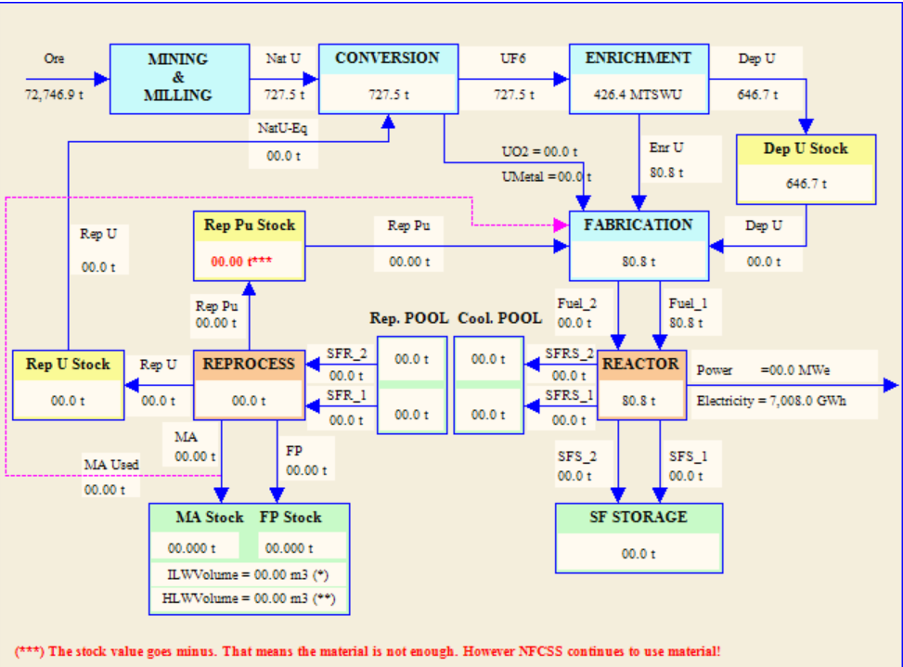

FIG. 1. Material flow diagram simulated in NFCSS

Incorporating the escalation rate is essential for accurate fuel cost calculations. Assuming that fuel costs can be approximated by the equation ${ F}_{t}=F_{0}⋅(1+s_{j})^{t}$, where s_{j} ​ represents the escalation rate and F₀ ​ denotes the initial annual fuel expenditure at t = 0, Equation (8) can be transformed accordingly
$\sum_{t=0}^{T}{\frac{F_{t}}{{\left(1+r\right)}^{t}}}=\sum_{t=0}^{T}{\frac{1}{(1+r)^{t}}}⋅\left(\sum_{j }{c_{j}⋅{\left(1+s_{j}\right)}^{t}{⋅m}_{j}(t)}\right)$ (9)
TABLE 1. LIST OF FUEL CYCLE COSTS
NFCSS mass flows | Fuel cycle steps | Unit
NatU(tHM) | 1. Natural U cost (U3O8 cost) | $/kgU
ConversionUF6(tHM) | 2. Conversion cost (U3O8 to UO2) | $/kgHM
ConversionUO2(tHM) | 2. Conversion cost ( UO2) | $/kgHM
SWU(MTSWU) | 3. Enrichment cost (from natural U to enriched U) | $/kgSWU
FF_1(tHM) | 4. Fuel 1 fabrication cost | $/kgHM
FF_2(tHM) | 5. Fuel 2 fabrication cost | $/kgHM
SFS1(tHM) | 6. Storage/Disposal of spent fuel 1 for open cycle | $/kgHM
SFS2(tHM) | 7. Storage/Disposal of spent fuel 1 for open cycle | $/kgHM
SFRSCPSto1(tHM) | 8. Cooling SF1 cost | $/kgHM/y
SFRSCPSto2(tHM) | 9. Cooling SF2 cost | $/kgHM/y
SFRSRPSto1(tHM) | 10. Repro storage SF1 cost | $/kgHM/y
SFRSRPSto2(tHM) | 11. Repro storage SF2 cost | $/kgHM/y
SFR1(tHM) | 12. Reprocessing cost for SF1 | $/kgHM
SFR2(tHM) | 13. Reprocessing cost for SF2 | $/kgHM
RepPuAccu(tHM) | 14. Pu storage cost | $/kg/y
RepPuStock(tHM) | 15.Pu price | $/kg
RepFPStock(t) | 16. HLW disposal cost | $/kg
Note on boundary condition impact on fuel cycle generation cost
If an NPP unit is built in one of the last periods, its lifetime can exceed the calculation horizon.
In this case, minor variations in results may occur compared to scenarios where the lifespans of all reactors fall within the considered timeframe.
- Fuel Cycle Cost Template and User instructions for its utilizing
The Fuel Cycle Cost (FCC) template is a specialized Excel tool designed to assist users in calculating and analyzing costs associated with various stages of the nuclear fuel cycle.
The FCC template structure
The FCC template is organized into four worksheets, each serving a specific function:
- Input: This sheet is designated for entering economic data required for the fuel cycle cost analysis. Users input includes discount rate, fuel cycle costs, and escalation rate.
- Intermediate Calculation: This worksheet performs the necessary computations based on the input data and material flows from NFSCC calculation. It processes the data to generate intermediate results that are essential for the output result.
- Output: This sheet presents the results derived from the intermediate calculations. It provides a cumulative discounted cost, levelized generation fuel cost and their components.
- Results_MF: This worksheet is dedicated to presenting the material flow results from the Nuclear Fuel Cycle Simulation System (NFCSS) calculations. It provides the material flows within the fuel cycle, as computed by the NFCSS.

Getting Started
The first step is developing a scenario within the Nuclear Fuel Cycle Simulation System (NFCSS). This involves defining several key parameters:
  - Strategy Parameters: Nuclear Capacity Variants, Reprocessing-Recycling Strategies, Reactor-Type Mixture, Load Factors;
  - Fuel Parameters: Fuel Discharge Burnup, Fuel Enrichment, Tails Assay;
  - Control Parameters: MOX or ThO₂ Fuel Share, Use of Depleted or Enriched Uranium
After defining the parameters, run the scenario in NFCSS to perform the necessary calculations. The system will simulate the nuclear fuel cycle based on the input data, and generate results that include material flows, resource requirements, and waste arising.
Once the calculations are completed, export the material flow results for further analysis (Fig. 2):
- Navigate to the "SCENARIO CODE" page within NFCSS.
- Click on the "Export to Excel" button located at the top right corner of the page.
- This action will generate an Excel workbook containing sheets with detailed material flow results from the NFCSS calculation (Fig.3).
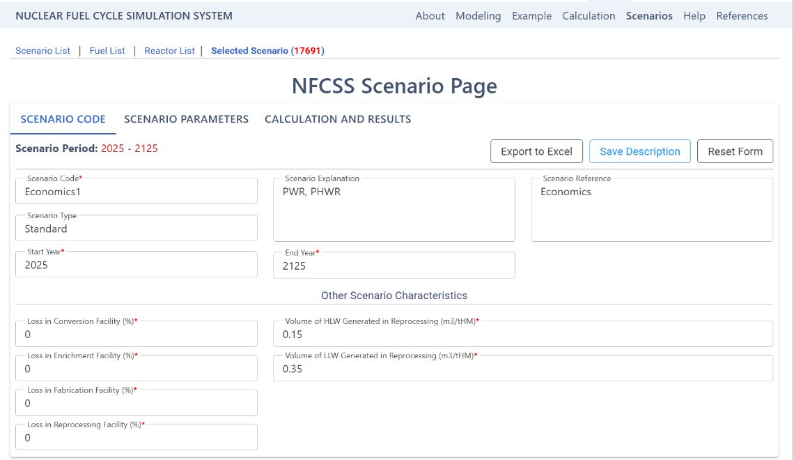
FIG. 2. Export NFCSS result to Excel

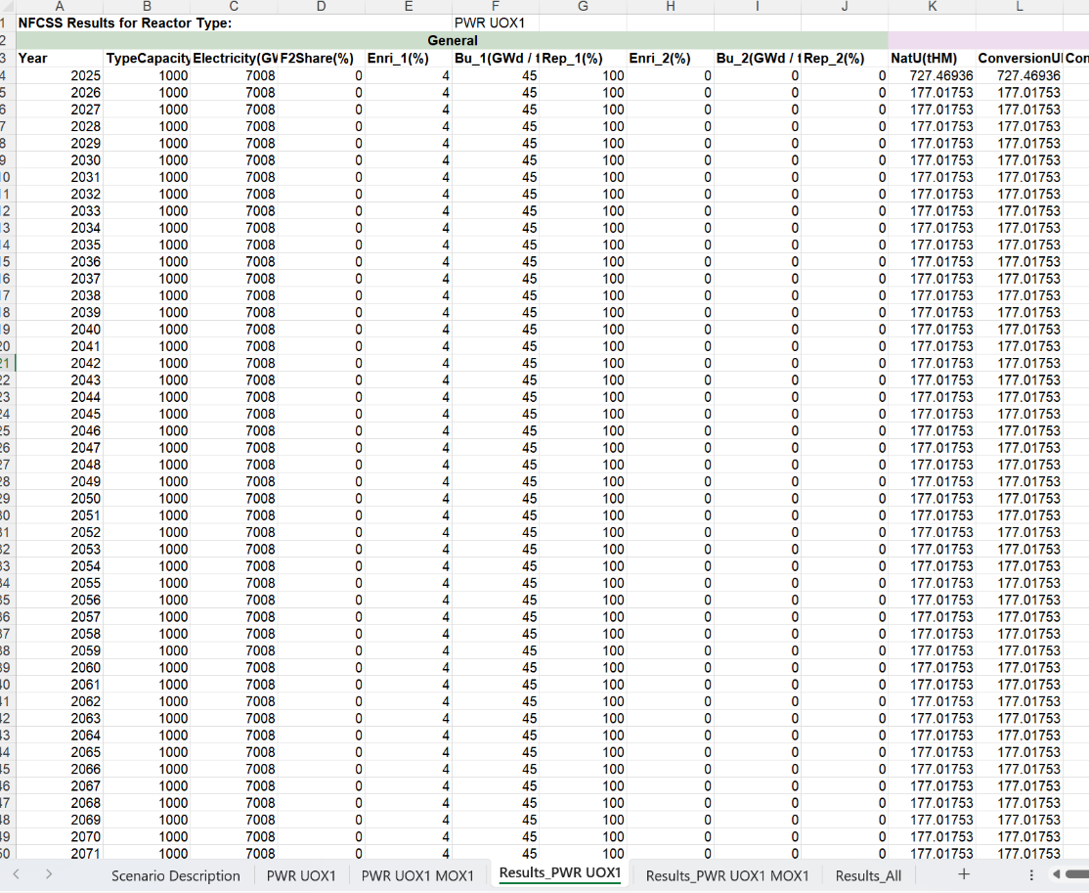
FIG. 3. Results for NFCSS mass flow calculation

Input data

The sheet “Input” includes input economic data for discount rate, costs and escalation rates for fuel cycle steps simulated with NFCSS (Fig. 4). Users need to populate the economic data in the light blue cells in the Input table.

Output data
The sheet “Output” provides results for the cumulative discounted fuel costs, levelized generation cost and their fuel step components (Fig. 5) calculated with formulas (6-9).

Intermediate result
The "Intermediate Result" sheet provides the calculation process (Fig. 6). It processes the data to generate cumulative discounted expenditure and levelized generation cost for the following fuel cycle steps: Natural U, Conversion, Enrichment, Fuel fabrication, Reprocessing, Spent fuel storage, Pu, Disposal, and Total fuel cycle. The mass flow data are copied from the "Result_MF" sheet, and input economic data are copied from the "Input" sheet.

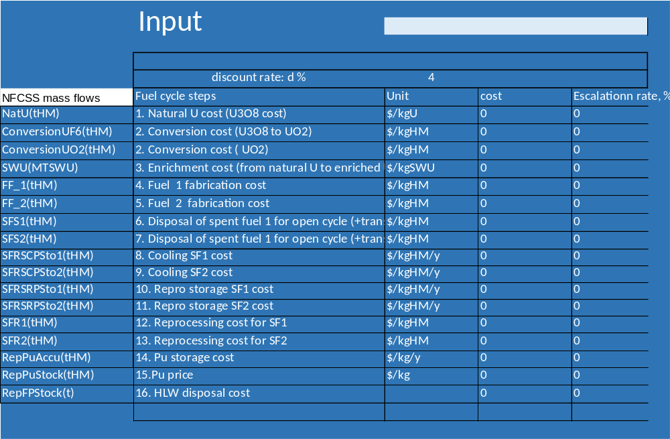

FIG. 4. Input data

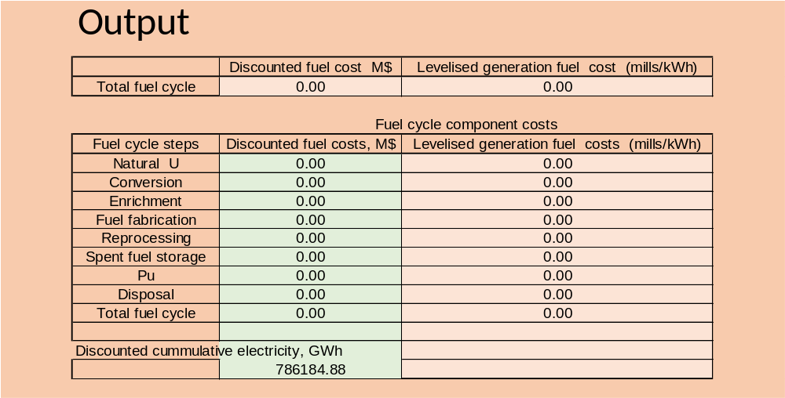

FIG. 5. Output data.

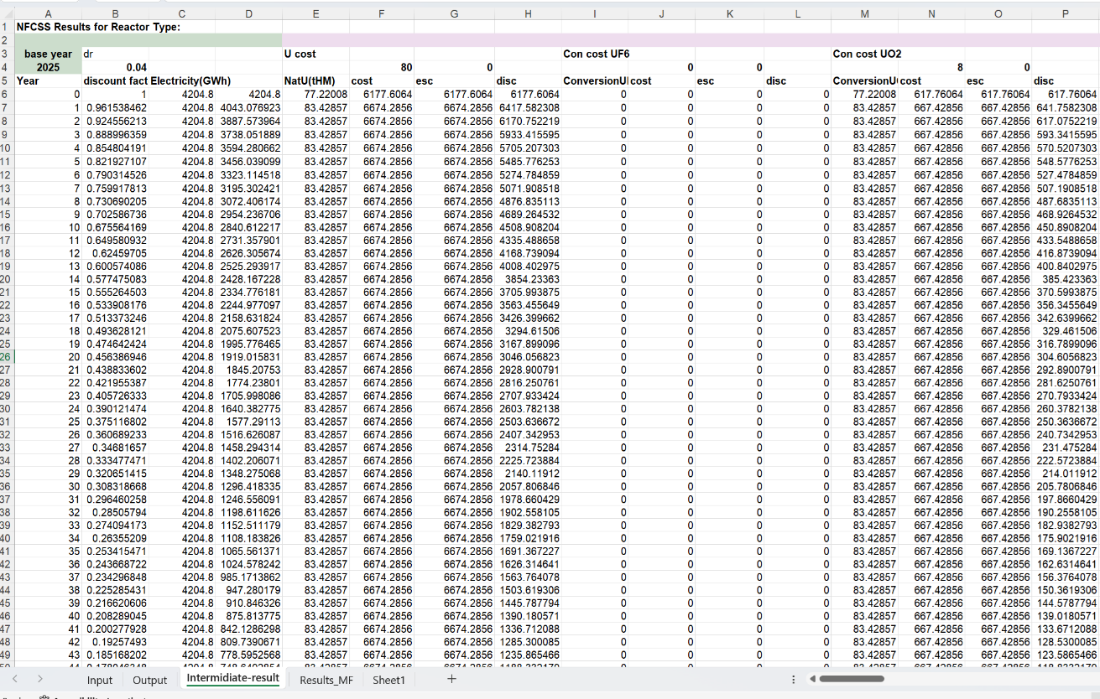

FIG. 6. Intermediate results.
- Example applications of the Excel template for Fuel Cycle Cost Calculation for PWR UOX, PHWR UOX, and PWR MOX reactor types.
Let s consider two scenarios as an examples of applications of the Excel template for Fuel Cycle Cost Calculation
- PWR and PHWR operating in open fuel cycle. Such a model of NFC is implemented in Sweden, Finland, Canada, etc.

- PWR UOX and PWR with two fuel types UOX and MOX operating in partly closed fuel cycle. Such a model of NFC is implemented in France, the Netherlands, Belgium, etc.
The FCC model is based on NFCSS material flows (Fig, 1). Technical data for reactors and fuel cycles are taken from NFCSS data base. Collection and compilation of consistent and reliable economic fuel cycle input data is a significant challenge for economic analysis, as data sources have great uncertainty [1, 4, 5-6, 8-12]. These uncertainties are often due to differences in national conditions and different user assumptions. Economic data with possible range used in this example are presented in Table 2. Discount rate is 4% for both scenarios. The escalation rates are supposed to be 0 for all fuel cycle steps.

TABLE 2. FUEL CYCLE UNIT COSTS
Fuel cycle steps | Unit | PWR UOX | PHWR | PWR UOX MOX
1. Natural U cost (U3O8 cost) | $/kgU | 40-80-100 | 40-80-100 | 40-80-100
2. Conversion cost (U3O8 to UO2) | $/kgHM | 8-10-15 |  | 8-10-15
2. Conversion cost ( UO2) | $/kgHM |  | 5-8-12
3. Enrichment cost (from natural U to enriched U) | $/kgSWU | 100-110- 150 |  | 100-110- 150
4. Fuel 1 fabrication cost | $/kgHM | 250-275- 350 | 65-125 | 250-275-350
5. Fuel 2 fabrication cost | $/kgHM |  |  | 900-1000-1500
6. Disposal of spent fuel 1 for open cycle | $/kgHM | 300-400-500 | 200 | 300-400-500
7. Disposal of spent fuel 2 | $/kgHM |  |  | 300-400-500
8. Cooling SF1 cost | $/kgHM/y | 4-5-6 |  | 4-5-6
9. Cooling SF2 cost | $/kgHM/y | 4-5-6 |  | 4-5-6
10. Repro storage SF1 cost | $/kgHM/y | 4-5-6 |  | 4-5-6
11. Repro storage SF2 cost | $/kgHM/y | 4-5-6 |  | 4-5-6
12. Reprocessing cost for SF1 | $/kgHM | 500-600-1200 |  | 500-600-1200
13. Reprocessing cost for SF2 | $/kgHM |  |  | 1000-1500-2000
14. Pu storage cost | $/kg/y |  |  | 2000
15.Pu price | $/kg |  |  | 2000
16. HLW disposal cost | $/kg | 300-400-500 |  | 300-400-500

Scenario 1 for PWR and PHWR operating in open fuel cycle

Figures 7 and 8 present the input data for Pressurized Water Reactors (PWR) and Pressurized Heavy Water Reactors (PHWR). Both reactor types share the same natural uranium costs. However, PHWRs benefit from lower costs in conversion, fuel fabrication, and spent fuel management. Notably, PHWRs do not require the enrichment process, which is a necessary and costly step in the PWR fuel cycle.

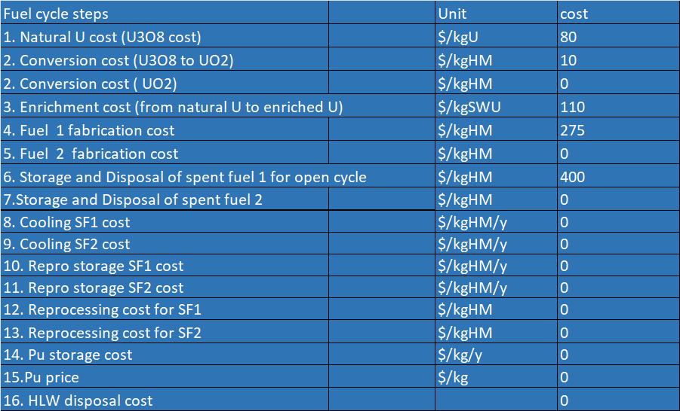 | 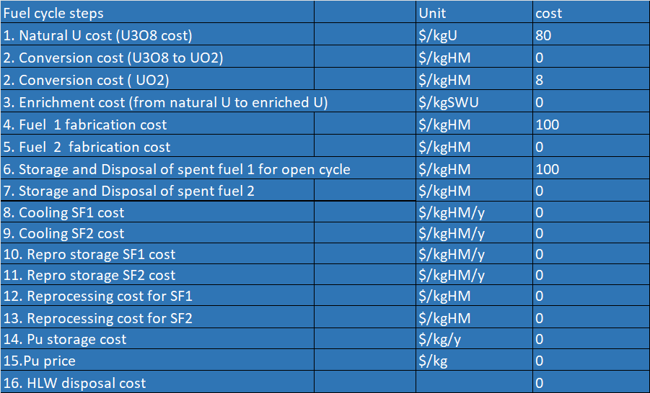
FIG. 7. Input for PWR in open fuel cycle | FIG. 8. Input for PHWR in open fuel cycle

Figures 9 and 10 illustrate outputs for the cumulative discounted costs and levelized generation costs for PWR and PHWR. These figures detail the contributions from various components, including natural uranium, conversion, enrichment, fuel fabrication, and disposal. Additionally, pie charts depict the percentage contribution of each component, providing a clear visual comparison between the two reactor types.

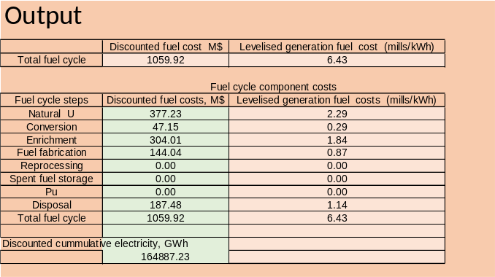 | 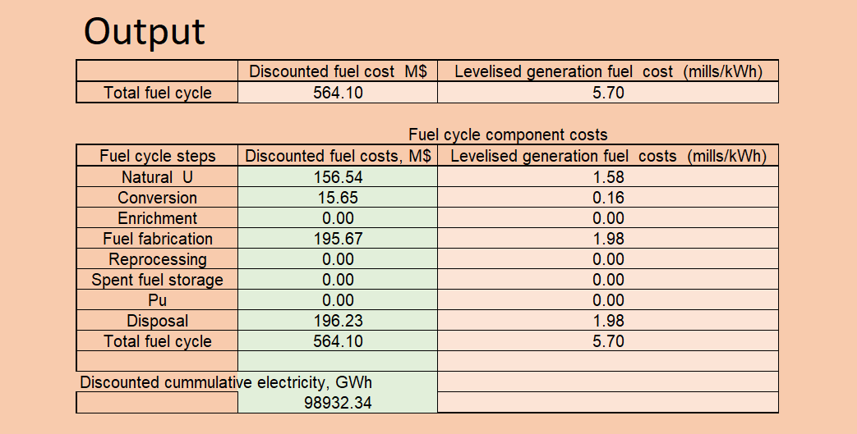
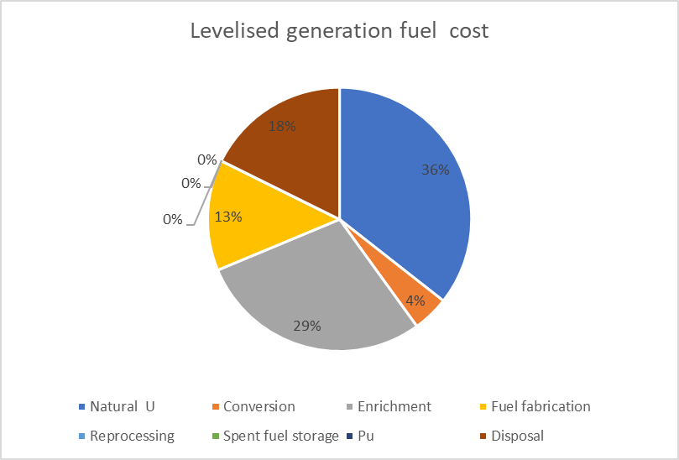 | 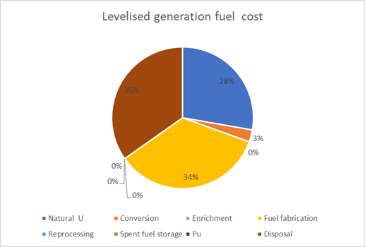
FIG. 9. Output for PWR in open fuel cycle | FIG. 10. Output for PHWR in open fuel cycle

Scenario 2 PWR UOX and PWR with two fuel types UOX and MOX operating in partly closed fuel cycle

​Figures 11 and 12 present the input data for two reactor types:​

- PWR with reprocessing spent uranium oxide (UOX) fuel to extract usable plutonium, which is then stored for potential future use,
- PWR using two fuel types UOX and MOX with reprocessing only of UOX fuel and storage of MOX.​
The cost data include front-end costs for UOX fuel, reprocessing costs for UOX fuel, and costs for MOX fuel fabricated from separated plutonium and depleted uranium. Additionally, there are costs associated with plutonium storage. If there is insufficient plutonium to fabricate MOX fuel, additional expenses are incurred to address this deficit.
Figures 13 and 14 illustrate the cumulative discounted costs and levelized generation costs for Pressurized Water Reactors (PWRs) employing reprocessing strategies and those utilizing both Uranium Oxide (UOX) and Mixed Oxide (MOX) fuels. These figures detail the contributions from various components of both open and closed fuel cycles, including natural uranium, conversion, enrichment, fuel fabrication, reprocessing, plutonium costs, storage, and disposal costs. Pie charts depict the percentage contribution of each component. By examining the percentage contributions of each component through the pie charts, user can identify key fuel cost drivers and possibility for its reduction.

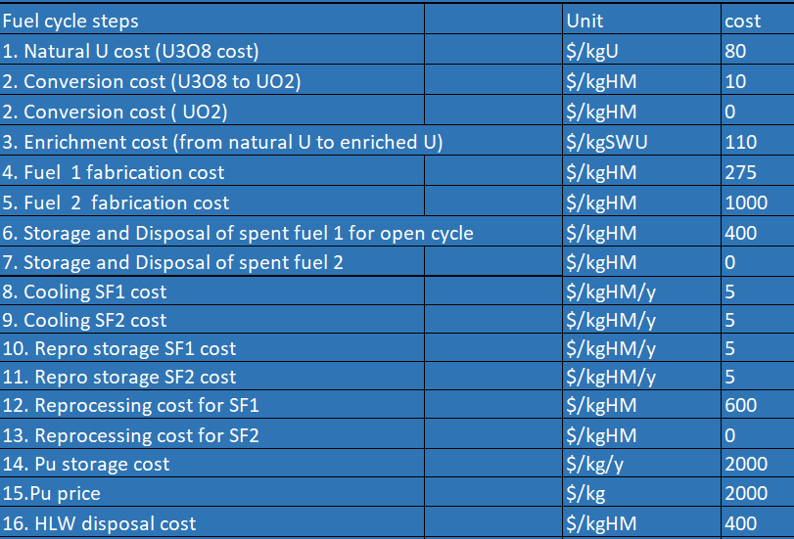 | 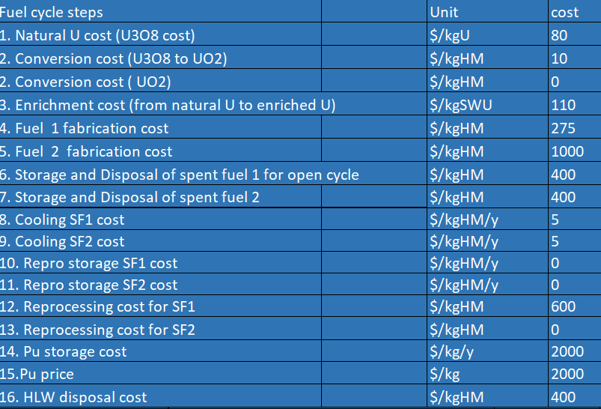
FIG.11. Input for PWR with reprocessing | FIG. 12. Input for byR UOX MOX

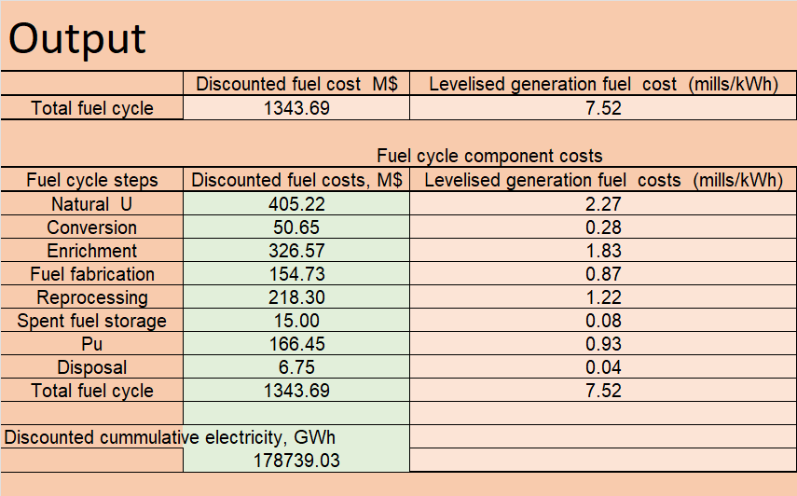 | 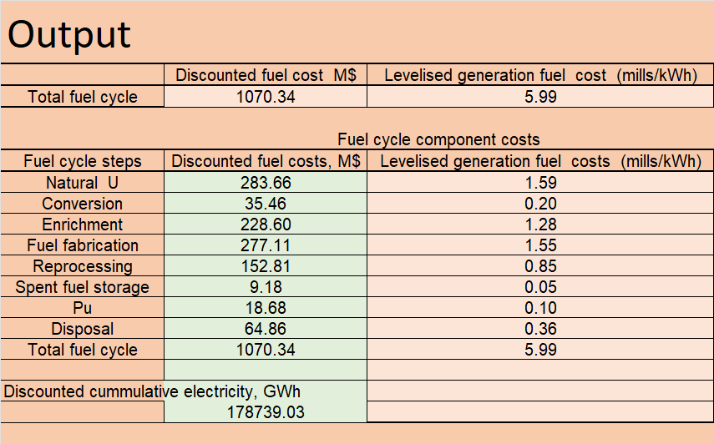
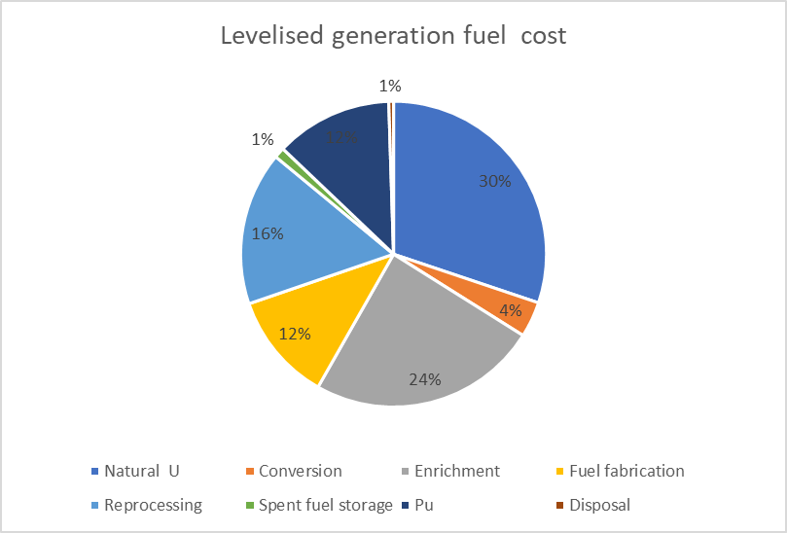 | 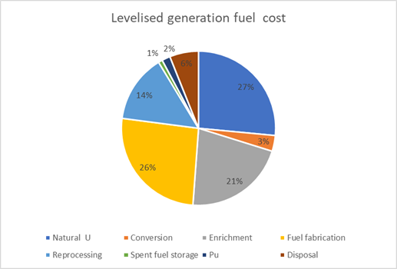
FIG. 13. Output for PWR with reprocessing | FIG. 14. Output for PWR UOX MOX

- Overall Fuel Cycle Cost calculation for a combination of reactor types based on the NFCSS scenario.
Template for overall Fuel Cycle Cost calculation for a combination of thermal reactor types

Economic estimation for the overall scenario can be performed using the overall Fuel Cycle Cost Calculation template, which accommodates combinations of reactor types. This template includes only Input & Output sheet (Figures 15–17). This sheet consolidates data on fuel cycle discounted costs and discounted cumulative electricity generation for each reactor type, sourced from the respective reactor type templates as shown in Figure 18. Additionally, it incorporates input data for plutonium flows for each reactor type, also derived from the reactor type templates illustrated in Figure 19.​
The sheet further provides an aggregated output calculation for the combination of reactor types utilized in the scenario. This output presents results for cumulative discounted fuel costs, levelized generation costs, and their respective fuel cycle component breakdowns depicted in Figure 16 across all reactor types considered in the scenario.​
​

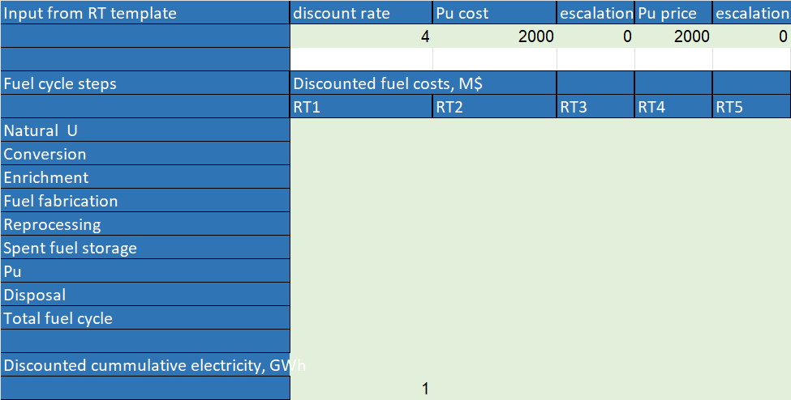 | 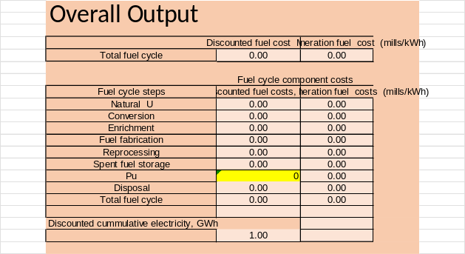
Fig. 15 Input data for fuel cycle discounted costs and discounted cumulative electricity for each reactor type | Fig.16 Overall output for cumulative discounted fuel costs, levelized generation costs, and their respective fuel cycle component breakdowns

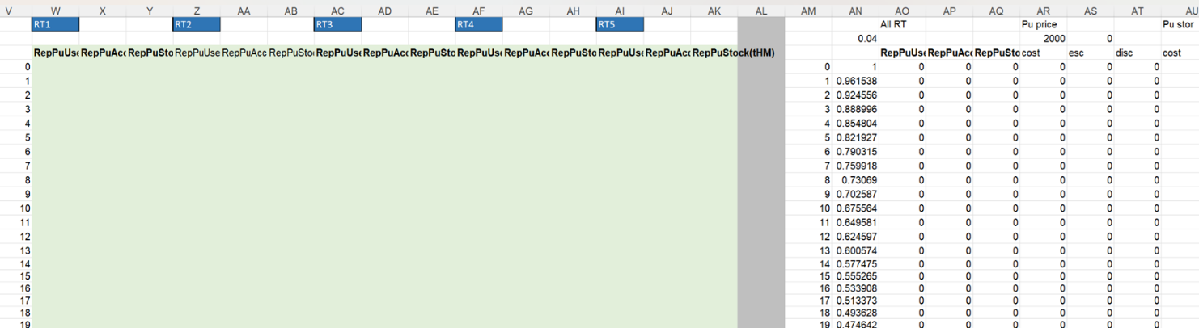

Fig. 17 Input data for Plutonium flows for each reactor type.

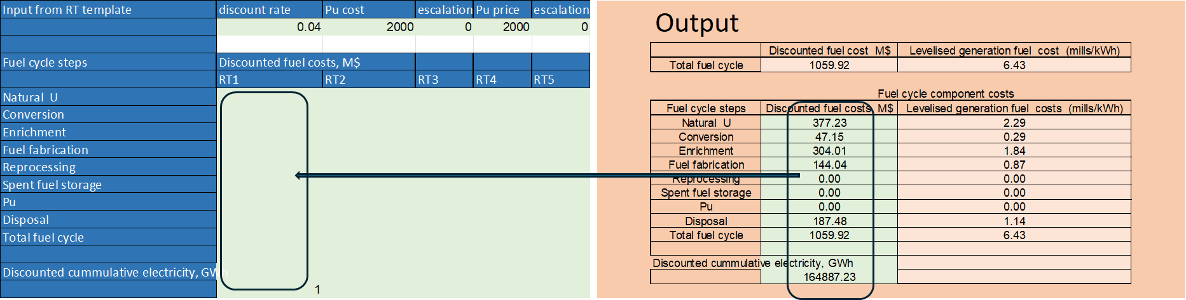

Fig. 18 Data on fuel cycle discounted costs and discounted cumulative electricity generation for each reactor type, sourced from the respective reactor type templates

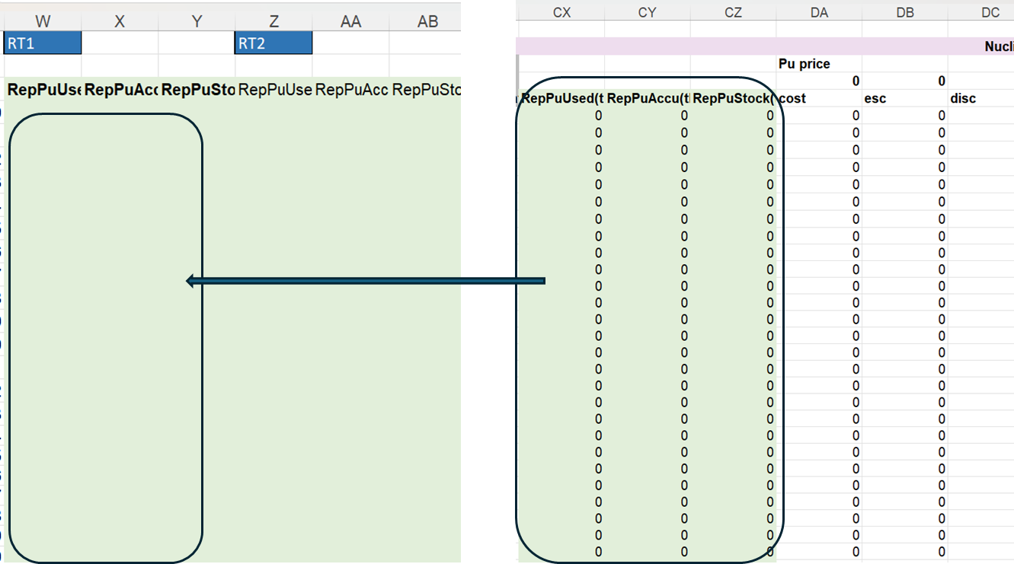
Fig. 19 Input data for plutonium flows for each reactor type, also derived from the reactor type templates

Scenario 1 for PWR and PHWR operating in open fuel cycle

​Figure 20 presents the input data for Scenario 1, involving PWR, referred to as RT1 and PHWR, referred to as RT2 operating in an open fuel cycle. The input data for the components of cumulative discounted costs and discounted cumulative electricity for these reactors are extracted from the outputs for the PWR (Figure 9) and the PHWR (Figure 10). In this open fuel cycle scenario, plutonium flows are zero. These data are processed in accordance with Formula 5. The output data for the overall scenario, detailing the discounted fuel costs, their components, and the levelized discounted cost for the entire scenario based on the two reactor types, are presented in Figures 21 and 22.​

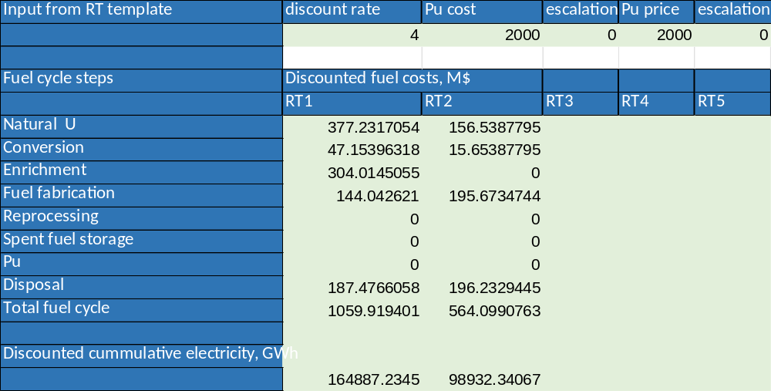
Fig. 20 Input data for Scenario 1, involving a PWR (RT1) and a PHWR (RT2) operating within an open fuel cycle

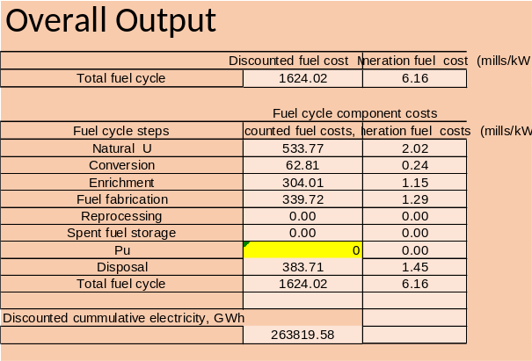 | 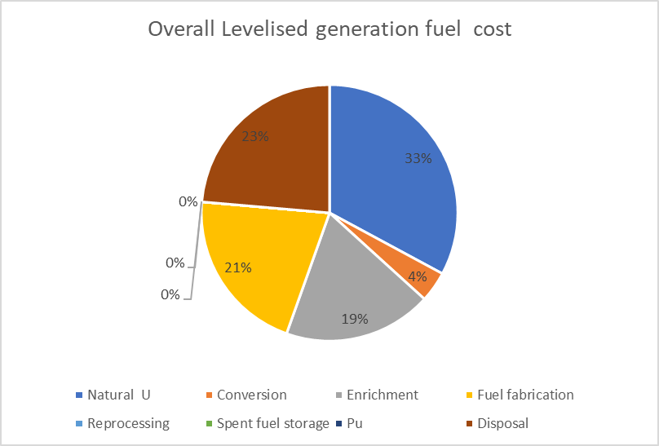
Fig. 21 The output data for the overall scenario 1 | Fig. 22 Pie chart output for the overall scenario 1

Scenario 2 PWR UOX and PWR with two fuel types UOX and MOX operating in partly closed fuel cycle with a single plutonium recycling from UOX spent fuel

Figures 23 and 24 present the input data for Scenario 2, which involves PWR using UOX and MOX fuels​. In this partially closed fuel cycle scenario only UOX spent fuel is reprocessed. The input data for cumulative discounted costs and discounted cumulative electricity are extracted from the outputs for PWR UOX with reprocessing (Figure 13) and PWR UOX MOX (Figure 14). Plutonium flows for the scenario are calculated based on the plutonium flows for each reactor, with associated costs determined accordingly. The overall scenario results, including discounted fuel costs, their components, and the levelized discounted cost for the entire scenario based on these two reactor types, are presented in Figures 25 and 26.​

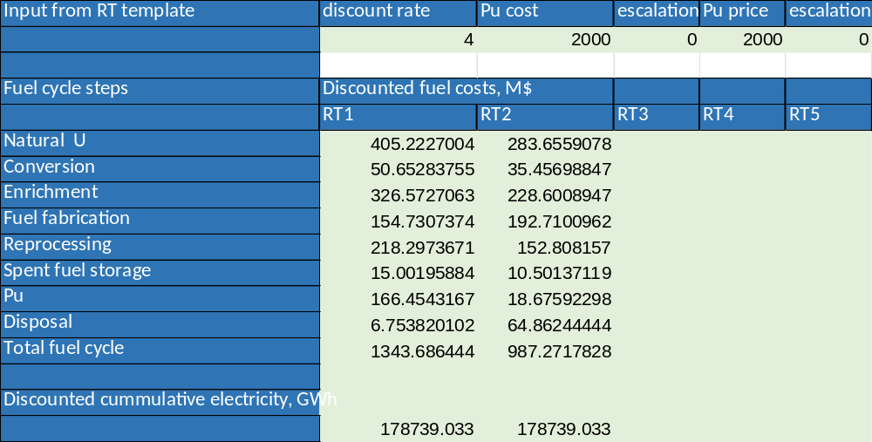
Fig. 23 Input data for Scenario 2 with PWR using UOX and MOX fuels

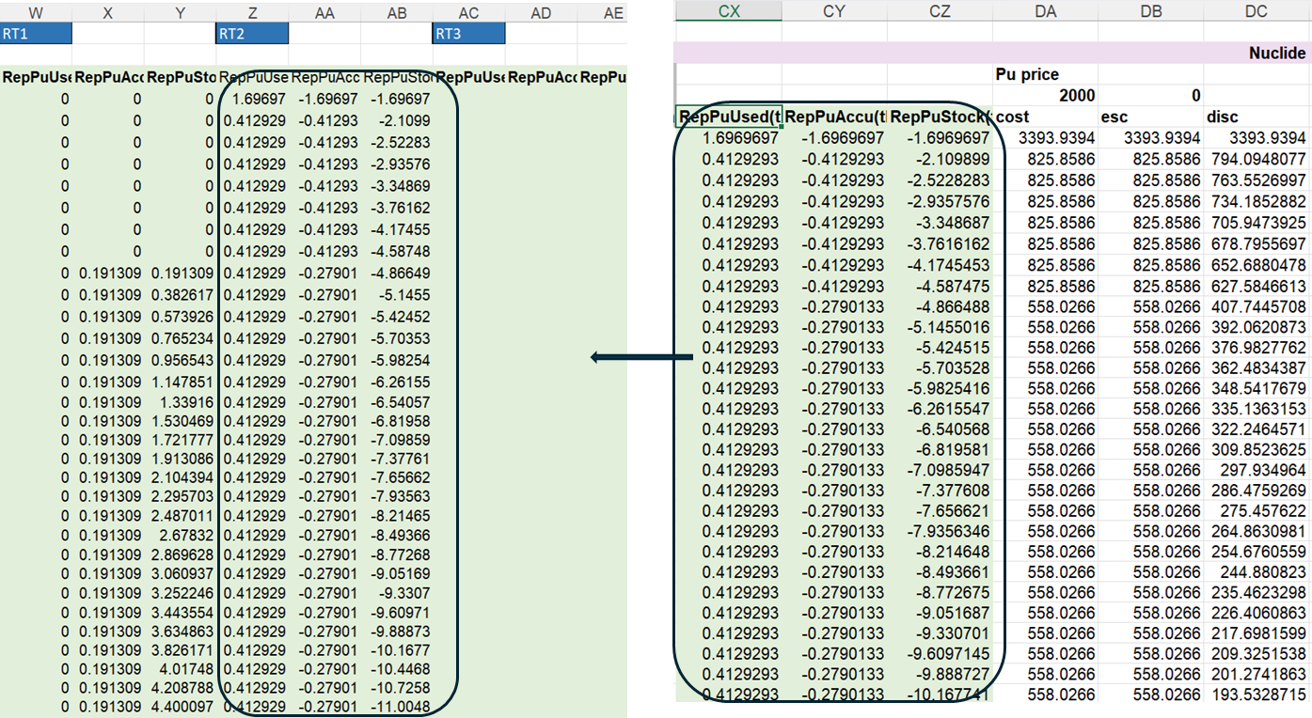
Fig. 24 Input data for plutonium flows in Scenario 2 with PWR using UOX and MOX fuels ​

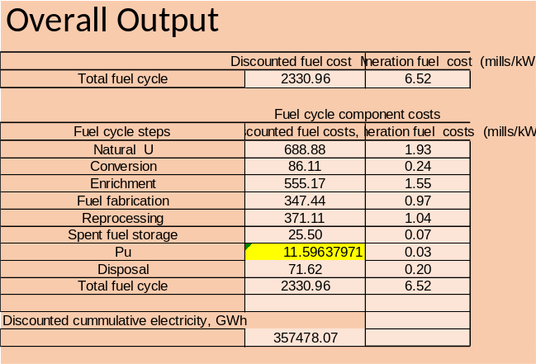 | 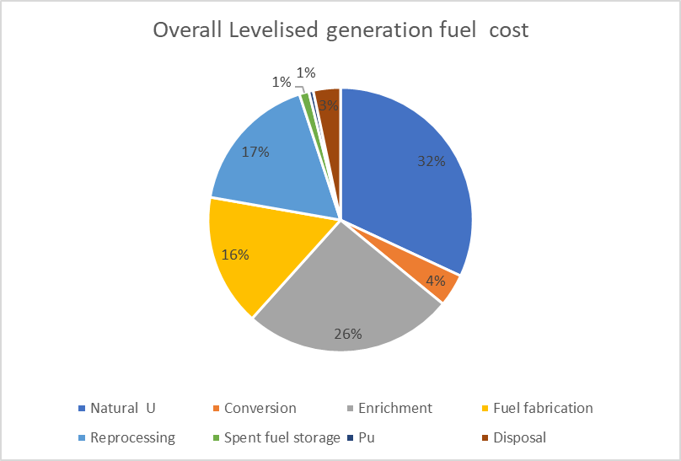
Fig. 25 Output for the overall scenario 2 | Fig. 26 Pie chart output for the overall scenario 2

5. References
[1] INTERNATIONAL ATOMIC ENERGY AGENCY, INPRO Methodology for Sustainability Assessment of Nuclear Energy Systems: Economics, IAEA Nuclear Energy Series No. NG-T-4.4, IAEA, Vienna (2014).
[2] INTERNATIONAL ATOMIC ENERGY AGENCY, Economic Evaluation of Alternative Nuclear Energy Systems: Supplementary Guidebook for INPRO Training on ASENES, TECDOC-IAEA 2014, Vienna (2022).
[3] INTERNATIONAL ATOMIC ENERGY AGENCY, Economic Evaluation of Bids for Nuclear Power Plants, TECHNICAL REPORTS SERIES No.396, International Atomic Energy Agency, Vienna 2000.
[4] INTERNATIONAL ATOMIC ENERGY AGENCY, Modelling Nuclear Energy Systems with MESSAGE: A Users’ Guide, IAEA Nuclear Energy Series No. NG-T-5.2, IAEA, Vienna (2016).
[5] INTERNATIONAL ATOMIC ENERGY AGENCY, Enhancing Benefits of Nuclear Energy Technology Innovation through Cooperation among Countries: Final Report of the INPRO Collaborative Project SYNERGIES, IAEA Nuclear Energy Series No. NF-T-4.9, Vienna (2018),
[6] INTERNATIONAL ATOMIC ENERGY AGENCY, Simulators for scenario analysis of nuclear energy systems, IAEA Training Course Series, , Vienna (in print).
[7] ORGANISATION OF ECONOMIC COOPERATION AND DEVELOPMENT NUCLEAR ENERGY AGENCY, The Economics of the Nuclear Fuel Cycle (1994).
[8] INTERNATIONAL ATOMIC ENERGY AGENCY, Role of Thorium to Supplement Fuel Cycles of Future Nuclear Energy Systems, A Report of the International Project on Innovative Nuclear reactors and Fuel Cycles (INPRO), IAEA Nuclear Energy Series, NF-T-2.4, IAEA, Vienna (2012).
[9] ORGANISATION OF ECONOMIC COOPERATION AND DEVELOPMENT NUCLEAR ENERGY AGENCY, The Economics of the Back End of Nuclear Fuel Cycle, Paris, (2013).
[10] Dixon, B. W.; Ganda, F. Williams, K. A, et al., Advanced Fuel Cycle Cost Basis, INL/EXT-17-43826, (2017).
[11] ORGANISATION OF ECONOMIC COOPERATION AND DEVELOPMENT NUCLEAR ENERGY AGENCY, Advanced Nuclear Fuel Cycles and Radioactive Waste Management, Paris (2006).
[12] ORGANISATION OF ECONOMIC COOPERATION AND DEVELOPMENT NUCLEAR ENERGY AGENCY, INTERNATIONAL ATOMIC ENERGY AGENCY, uranium 2020: Resources, Production and Demand OECD, Paris (2020).
[13] INTERNATIONAL ATOMIC ENERGY AGENCY, Invitation and Evaluation of Bids for Nuclear Power Plants, IAEA Nuclear Energy Series No. NG-T-3.9, IAEA, Vienna (2011).
[14] OECD-NEA, 1994, “The Economics of the Nuclear Fuel Cycle,” Section 4.3.2.6, Plutonium storage, 1994
[15] SHROPSHIRE, D.E., et al., Advanced Fuel Cycle Economic Analysis of Symbiotic Light-Water Reactor and Fast Burner Reactor Systems, INL/EXT-09-15254, Idaho National Laboratory, Idaho Falls, ID (2009).
[16] BUNN, M., FETTER, S., HOLDREN, J.P., VAN DER ZWAAN, B., The Economics of Reprocessing vs Direct Disposal of Spent Nuclear Fuel, Belfer Center for Science and International Affairs (2003).
[17] INTERNATIONAL ATOMIC ENERGY AGENCY, Training course series, Simulators for scenario analysis of nuclear energy systems, Vienna, ( in preparation)

Annex I List of Excel files
TABLE 1. LIST OF EXCEL FILES AND THEIR NAMES
# | File name | Note
1 | FCC Template for NFCSS | The Fuel Cycle Cost (FCC) template is a specialized Excel tool designed to assist users in calculating and analyzing costs associated with various stages of the nuclear fuel cycle.
2 | PWR FCC Template for NFCSS | Example application of the FCC Excel template for PWR UOX reactor type.
3 | PHWR FCC Template for NFCSS | Example application of the FCC Excel template for PHWR reactor types.
4 | PWR Repro FCC Template for NFCSS | Example application of the FCC Excel template for PWR reactor types with spent fuel reprocessing.
5 | PWR MOX UOX FCC Template for NFCSS | Example application of the FCC Excel template for PWR reactor types with two fuel types UOX and MOX operating in partly closed fuel cycle.
6 | Overall FCC Template for NFCSS | Overall Excel Template for Fuel Cycle Cost calculation for a combination of thermal reactor types
7 | Overall PWR&PHWR FCC Template for NFCSS | Example application of the overall Excel FCC template for Scenario with PWR and PHWR operating in open fuel cycle
8 | Overall PWR UOX&PWR MOX UOX FCC Template for NFCSS | Example application of the overall Excel FCC template for Scenario with PWR UOX and PWR MOX UOX operating in partly closed fuel cycle with a single plutonium recycling from UOX spent fuel
9 | NFCSS_Scenario 1 PWR&PHWR | Exported Excel file containing sheets with detailed material flow results from the NFCSS calculation for Scenario 1, for PWR and PHWR operating in an open fuel cycle.
10 | NFCSS_Scenario 2 PWR UOX&PWR MOX | Exported Excel file containing sheets with detailed material flow results from the NFCSS calculation for Scenario 1, for PWR UOX and PWR MOX UOX operating in partly closed fuel cycle with a single plutonium recycling from UOX spent fuel

Annex II IAEA tools for NES economic evaluation
There are several IAEA tools for NES modeling and assessment including economic analysis. Tools are developed internally by IAEA/INPRO and distributed free of charge to Member States upon request. The methodologies used are up-to-date and technology neutral. The structure of the model based on INPRO tools should be adapted to the question/problem that the expert wants to analyze.
The NESA Economics Support Tool (NEST) is designed for economic analysis of nuclear energy systems, enabling users to calculate Levelized Unit Electricity Cost (LUEC) and perform sensitivity and uncertainty analyses. NEST allows comparison of various power plants, including fossil (coal, gas), renewable (wind, solar), and nuclear options like Pressurized Water Reactors (PWR) and Heavy Water Reactors (HWR) in once-through fuel cycles, PWR with MOX fuel, fast reactors in closed fuel cycles (with or without breeding), and a simplified Reactor Toolkit model. It requires inputs like reactor power output, thermal efficiency, capacity factor, lifetime, fuel burnup, core power density, investment costs, construction schedules, fuel cycle costs, operation and maintenance costs, and discount rates. NEST outputs include LUEC and figures of merit such as NPV, IRR, and ROI, with LUEC components like uranium purchase, conversion, enrichment, fuel fabrication, and back-end costs, where uranium purchase and enrichment are the largest contributors, followed by back-end costs and fuel fabrication, with uranium conversion being the least costly. It allows performing uncertainty analysis using Monte Carlo simulation with statistical methods to model inputs as random variables. LUEC focuses on plant-specific costs, excluding grid connection, backup capacity, or environmental/social costs, limiting its scope to the plant itself. NEST has been applied in INPRO studies.
Nuclear Energy System Simulators (NES Simulators) comprise six tools for simplified modeling and analysis of nuclear energy systems, focusing on material flows and economic indicators to aid understanding of nuclear fuel cycles and costs. Model 1 evaluates annual and cumulative flows of fresh and spent fuel, and economic performance for a thermal reactor in a once-through fuel cycle without detailed fuel cycle processes. Model 2, more detailed, covers light-water and heavy-water reactors in an open fuel cycle, including front-end processes (mining, milling, conversion, enrichment, fuel fabrication) and back-end processes (cooling spent fuel, intermediate storage, geological disposal). Model 3 represents a partially closed fuel cycle with light-water reactors using UOX and MOX fuel, recycling plutonium once, covering front-end and back-end processes, with reprocessed UOX fuel waste sent to geological disposal. Model 4 models a fully closed fuel cycle with light-water and fast reactors, including detailed front-end (uranium mining, conversion, enrichment, fuel fabrication) and back-end processes (spent fuel storage, reprocessing, plutonium stocks, geological repository). Model 5 assists in simplified cash flow modeling for serial deployment of identical reactor units, evaluating economic metrics like total discounted cost, net present value, internal rate of return, payback period, return on investment, and levelized unit energy cost. Model 6 calculates discharged fuel content, focusing on UOX fuel isotopes, to support material flow analysis for back-end processes. These simulators provide simplified yet effective tools for understanding nuclear energy systems' material and economic dynamics.
The MESSAGE-NES method is an approach developed by INPRO for modeling nuclear energy systems (NES) using the MESSAGE software tool. MESSAGE is a flexible scenario development and optimization tool used to model various energy technologies by minimizing total discounted costs under defined constraints. While MESSAGE provides demo models for fossil, hydro, and renewables, it does not include nuclear systems by default. MESSAGE-NES addresses this gap by offering guidance on how to model nuclear power plants (NPPs) and fuel cycles, including datasets and methods to simulate NES with varying complexity—from simple representations of NPPs to detailed models including the full nuclear fuel cycle (NFC).
In simple models, NPPs are treated as electricity producers with basic input (fuel) and output (electricity and spent fuel). More detailed models include processes such as uranium mining, enrichment, fuel fabrication, reactor operation, and spent fuel management. These models help in assessing uranium and enrichment needs, spent fuel accumulation, and planning facility sizes, storage, and investment costs.
MESSAGE-NES allows users to explore the effects of reactor size, CO₂ limits, and different fuel cycle strategies on energy systems. It provides outputs such as uranium and SWU consumption, fuel requirements, and waste buildup, supporting long-term planning and sustainability assessments. The method has been successfully used in numerous national and international studies, analyzing various NES evolution scenarios—including once-through and closed fuel cycles, transmutation options, thorium use, and regional cooperation—demonstrating its applicability and value in nuclear energy planning.
The tools can be used separately, in tandem, or as a combined toolkit. Using these tools, it is possible to perform the following studies. In the first step, a simplified evaluation of NES can be carried out using Nuclear Energy System simulators. Then, a more sophisticated economic evaluation of NESs can be performed with the Nuclear Economics Support Tool (NEST). This tool evaluates the Levelized Unit Electricity Cost (LUEC), including its components, and analyzes sensitivity to various input factors. The next step is the evaluation of nuclear material flows and optimization of NES using the MESSAGE-NES model. This model conducts scenario analysis and optimizes NES structure, taking into account multiple resource and infrastructure constraints.
These tools can be applied to various reactor types, including PWR, HWR, and FR, although some modifications may be necessary for certain innovative types. They provide experts with insights into the potential and challenges of reactor deployment, supporting strategic planning for sustainable nuclear energy development.

